|  |
| --- |
| Getting Started with kubernetes on Windows |
|  |
|  |

|  |
| --- |
|  |

# Docker for Windows installation

Go to the URL below:

<https://store.docker.com/editions/community/docker-ce-desktop-windows>

Select get Docker as seen below

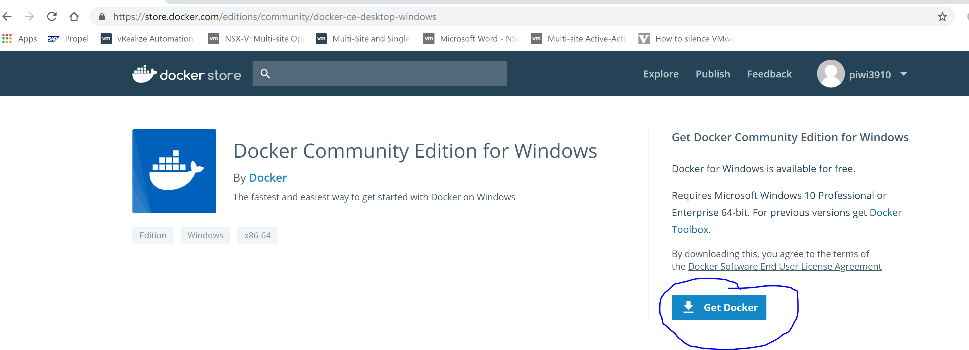

Execute the downloaded installer:

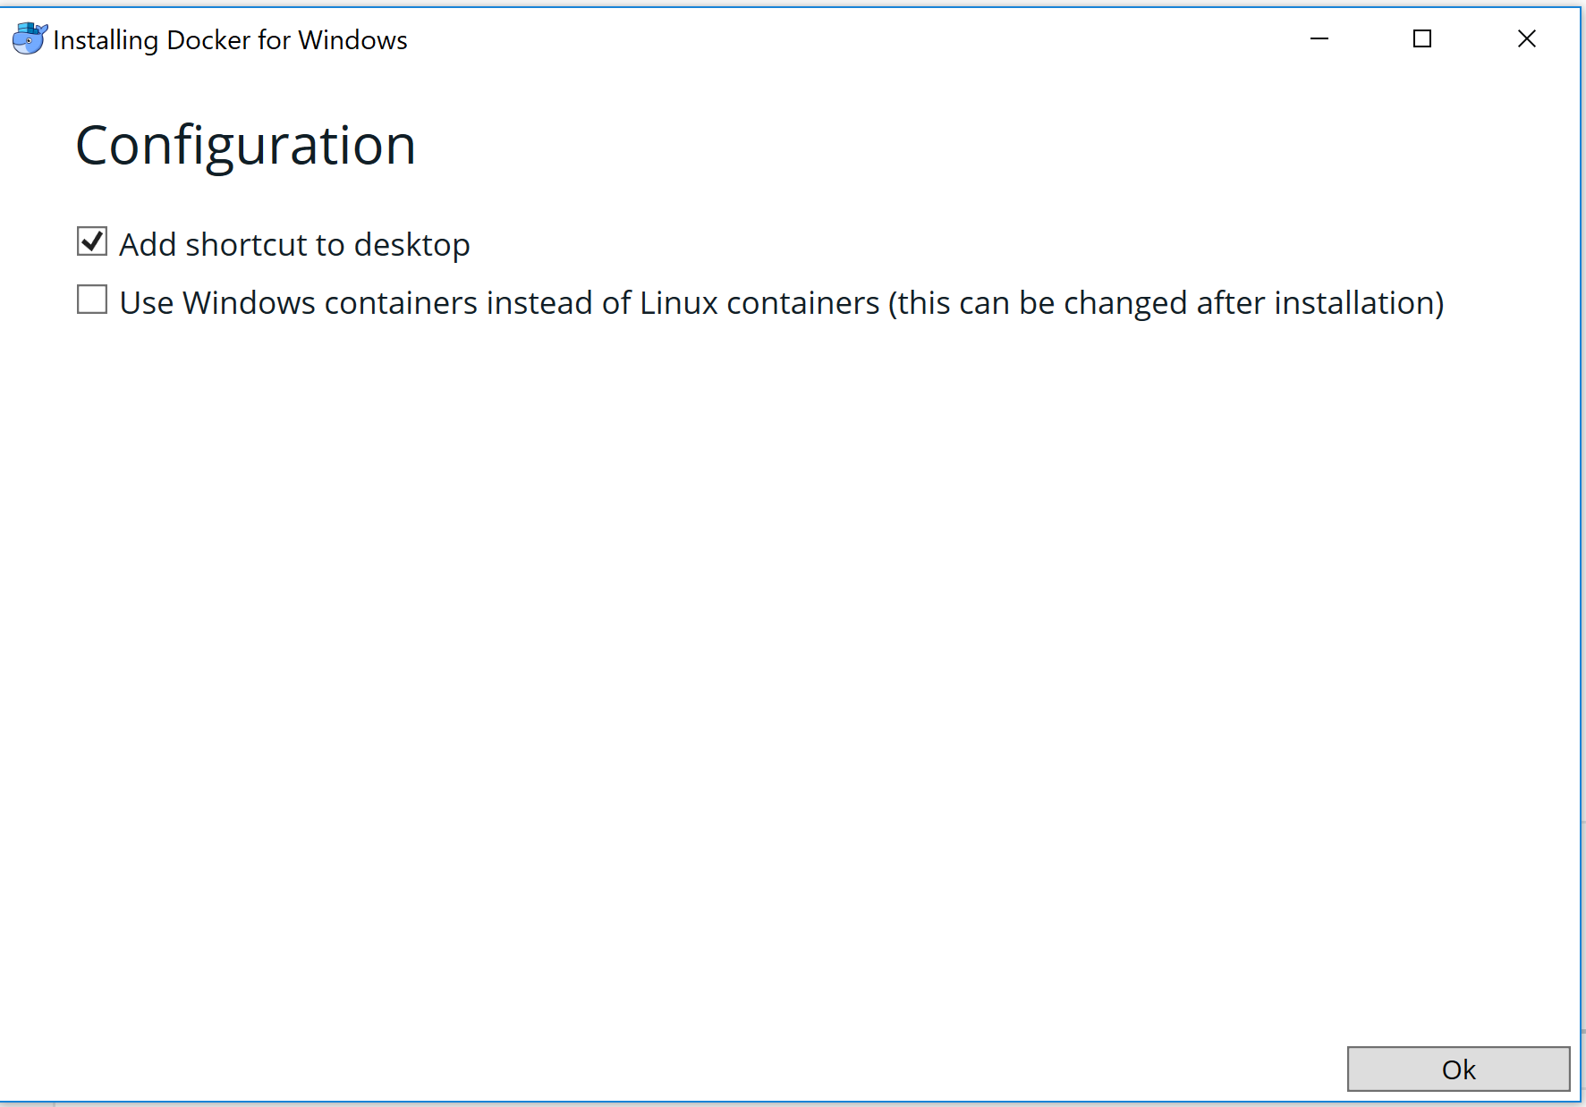

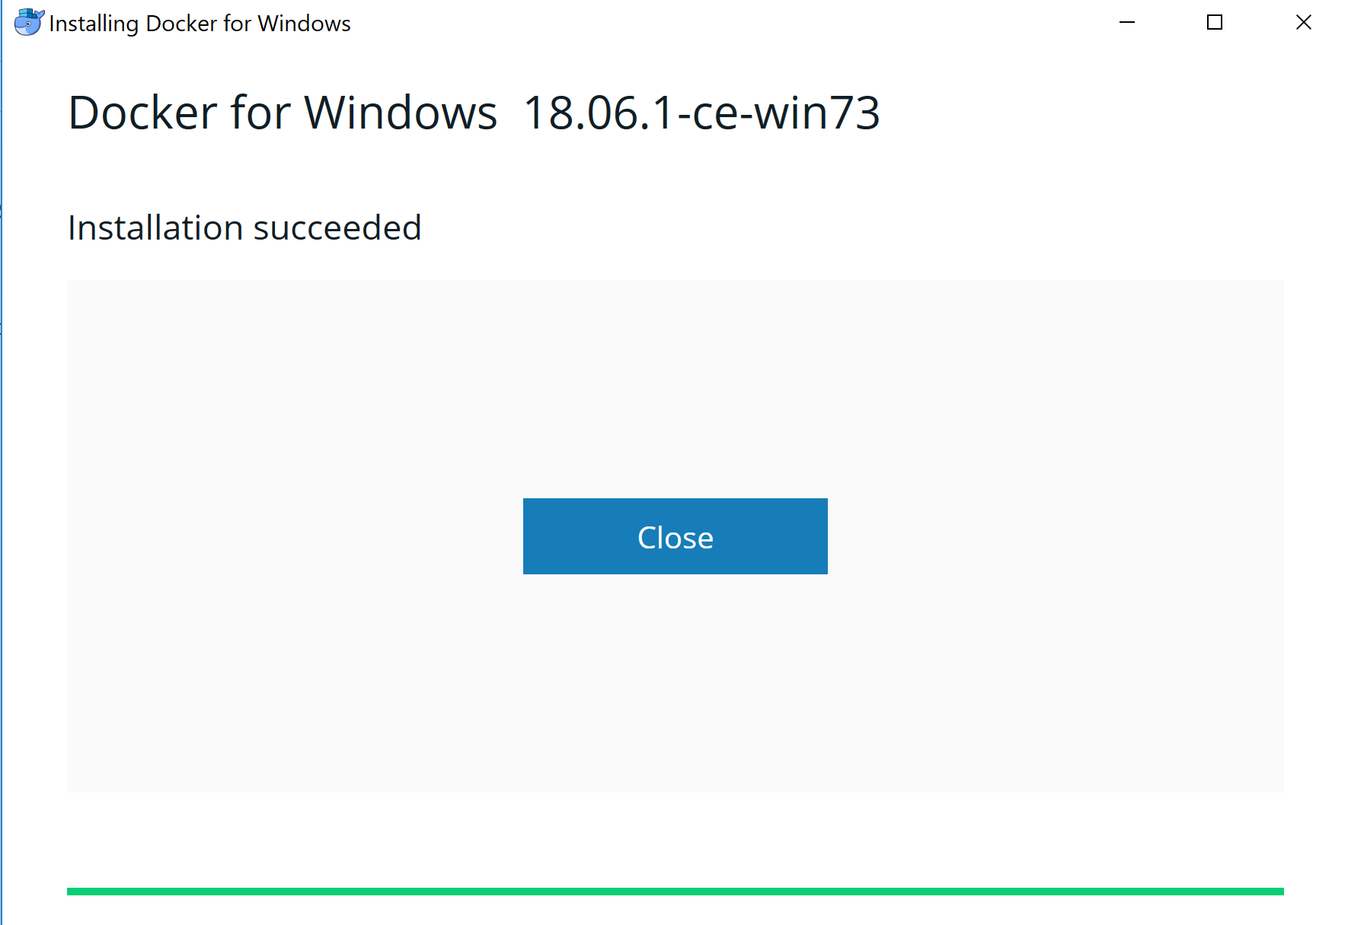

If you do not have hyper-v installed installed on your machine yet, you will see a similar popup as below.

If you use other hypervisors like Vmware workstation or Virtualbox they will stop working.

The commands to switch between the 2 hypervisors will be written in the appendix.

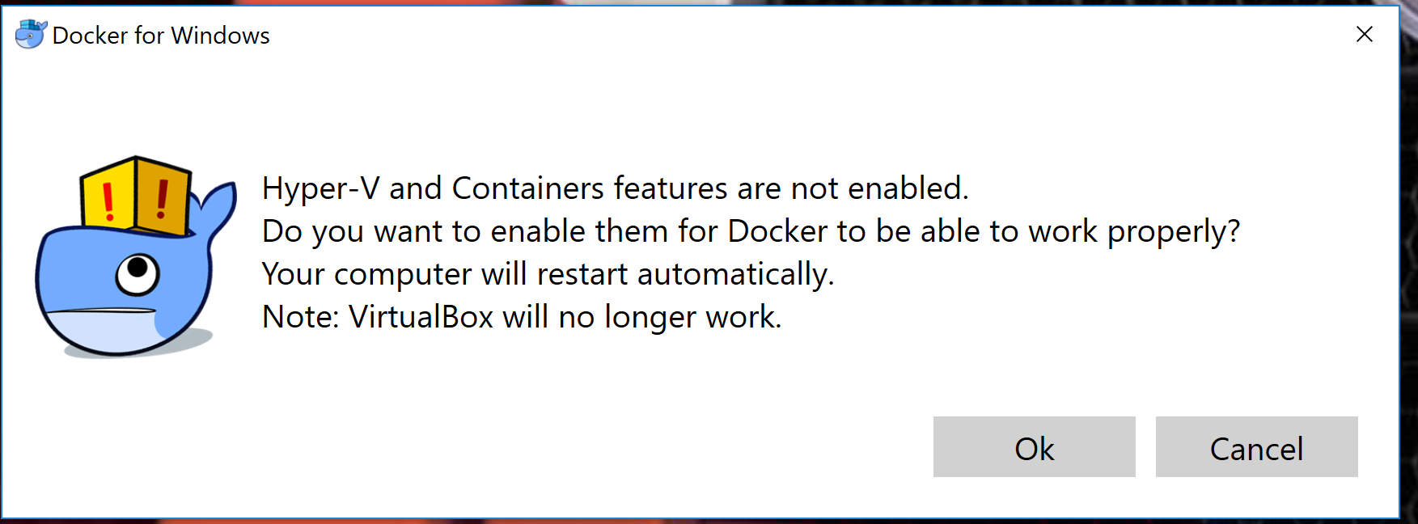

PC will reboot to activate Hyper-V

Click on the little whale in your task bar and select settings.

Click on kubernetes in the settings bar. And Select Enable Kubernetes and slect kubernetes as your default orchestrator below.

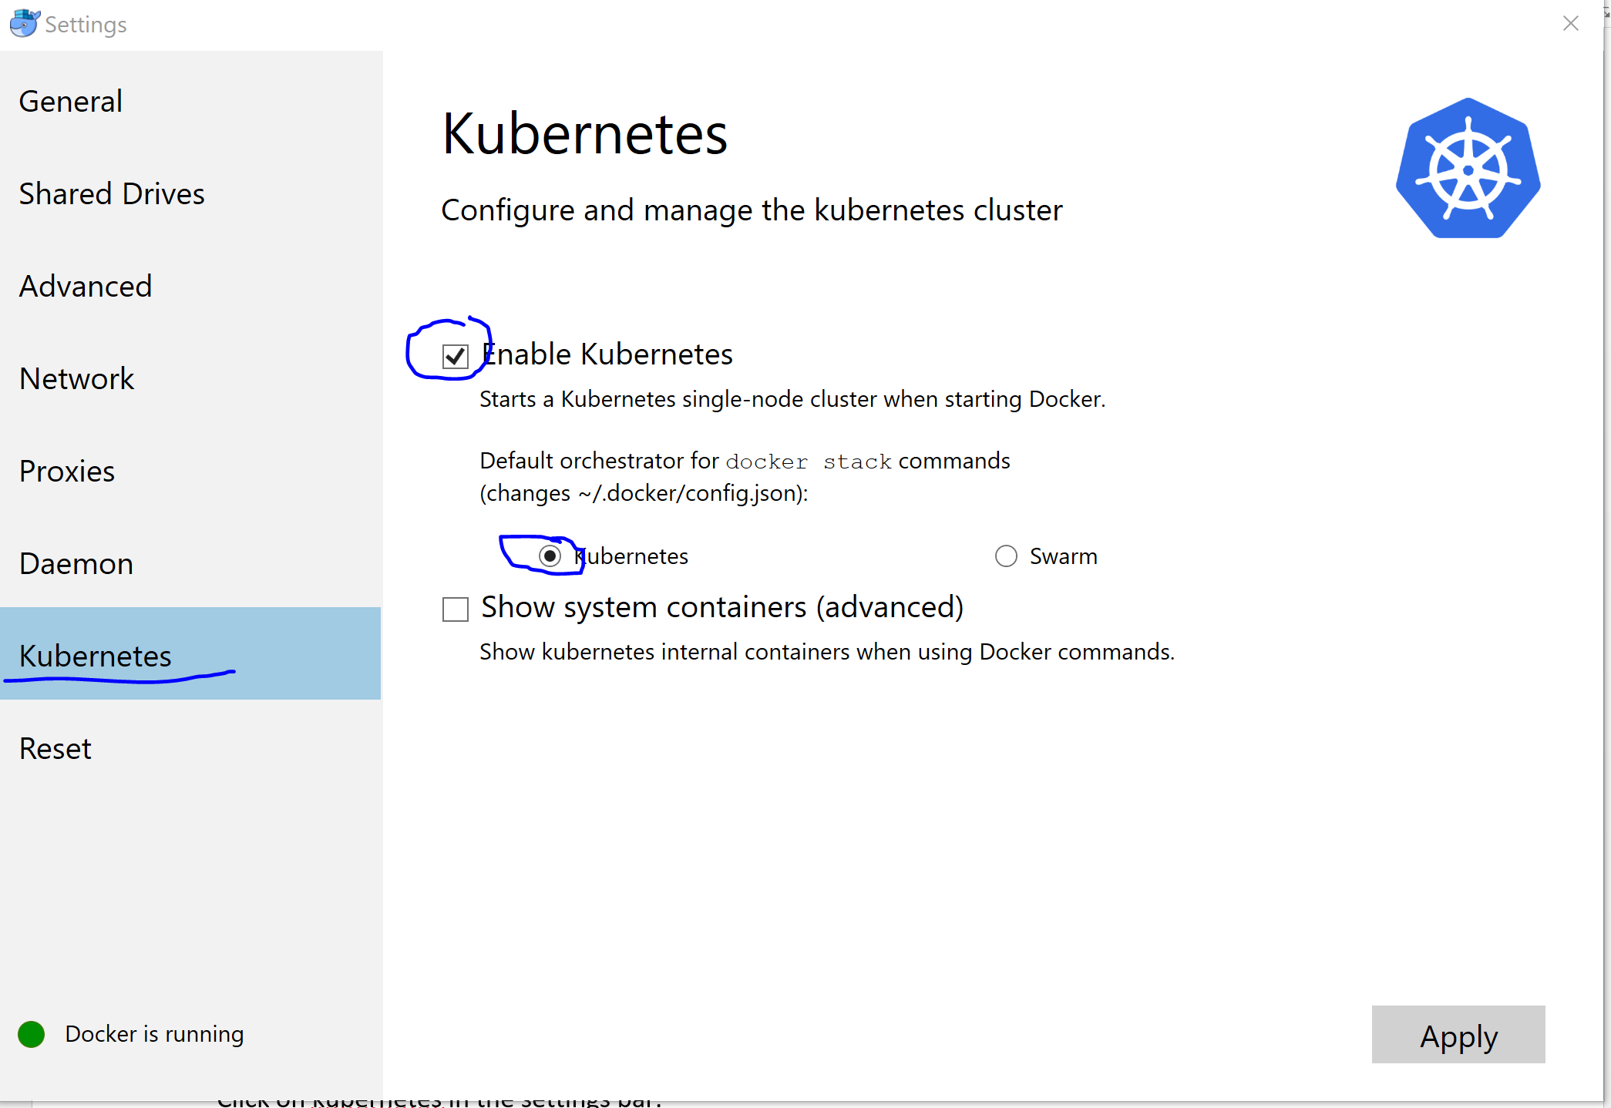

A download of all the needed containers will start in the background and the below popup will show.

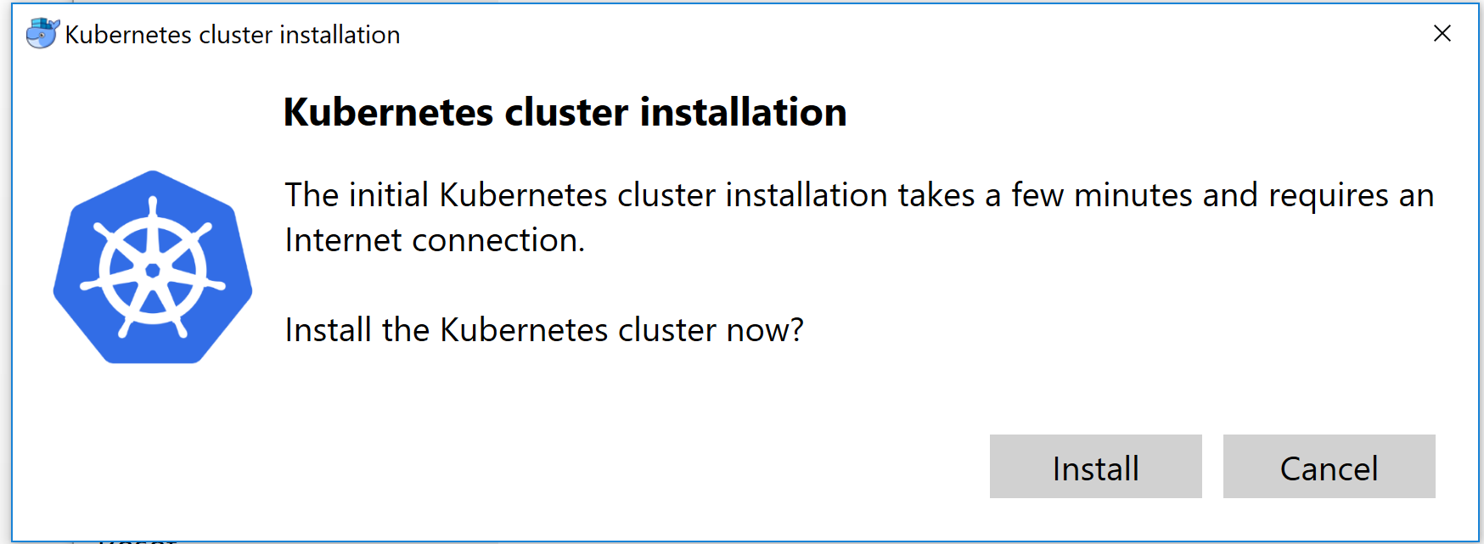

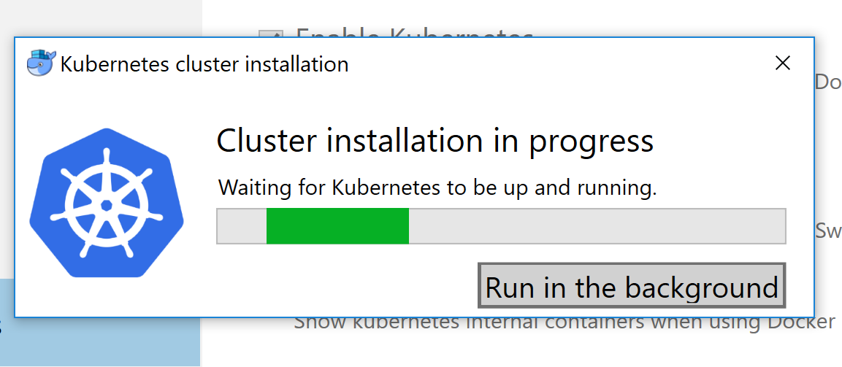

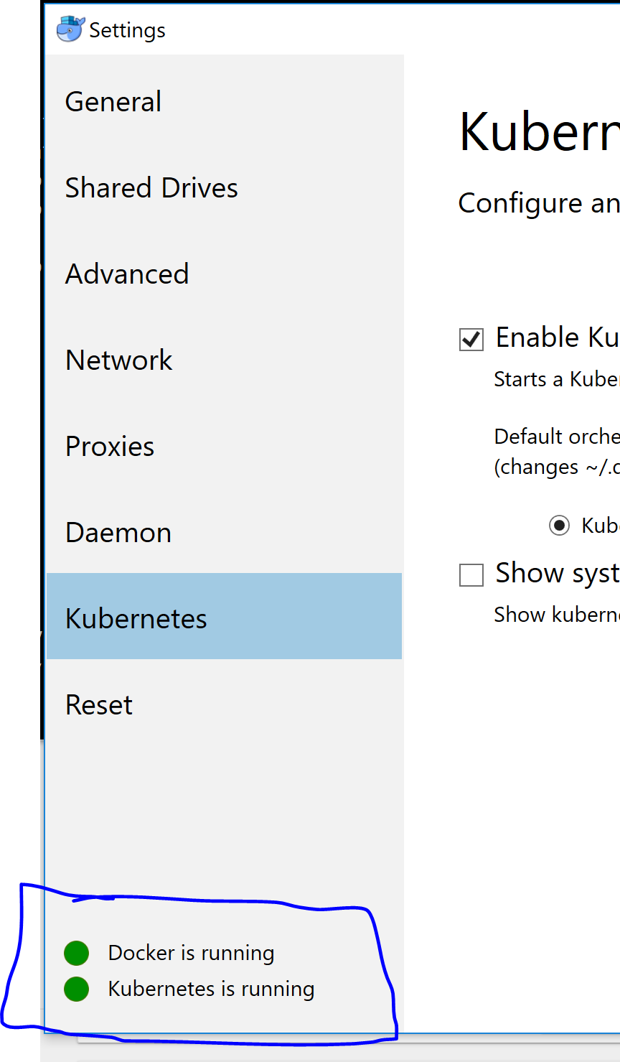

Check the status after its done in command prompt:

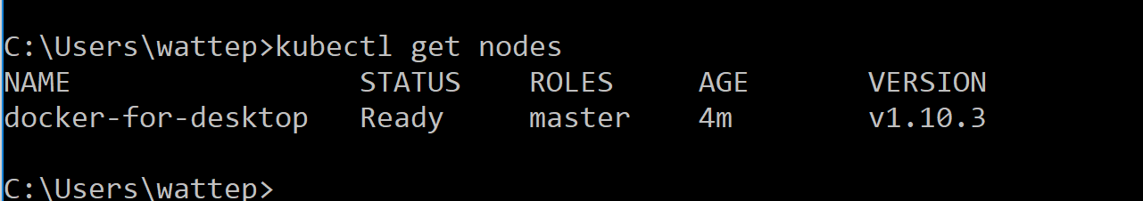

# Installing the Kubernetes Dashboard

kubectl apply -f https://raw.githubusercontent.com/kubernetes/dashboard/master/src/deploy/recommended/kubernetes-dashboard.yaml

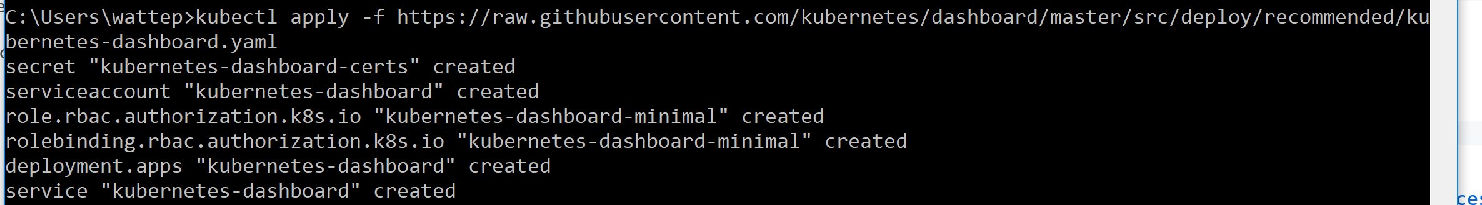

kubectl proxy

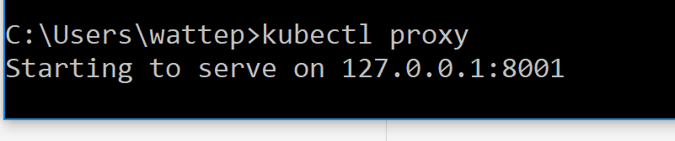

Don’t close the window!

<http://localhost:8001/api/v1/namespaces/kube-system/services/https:kubernetes-dashboard:/proxy/>

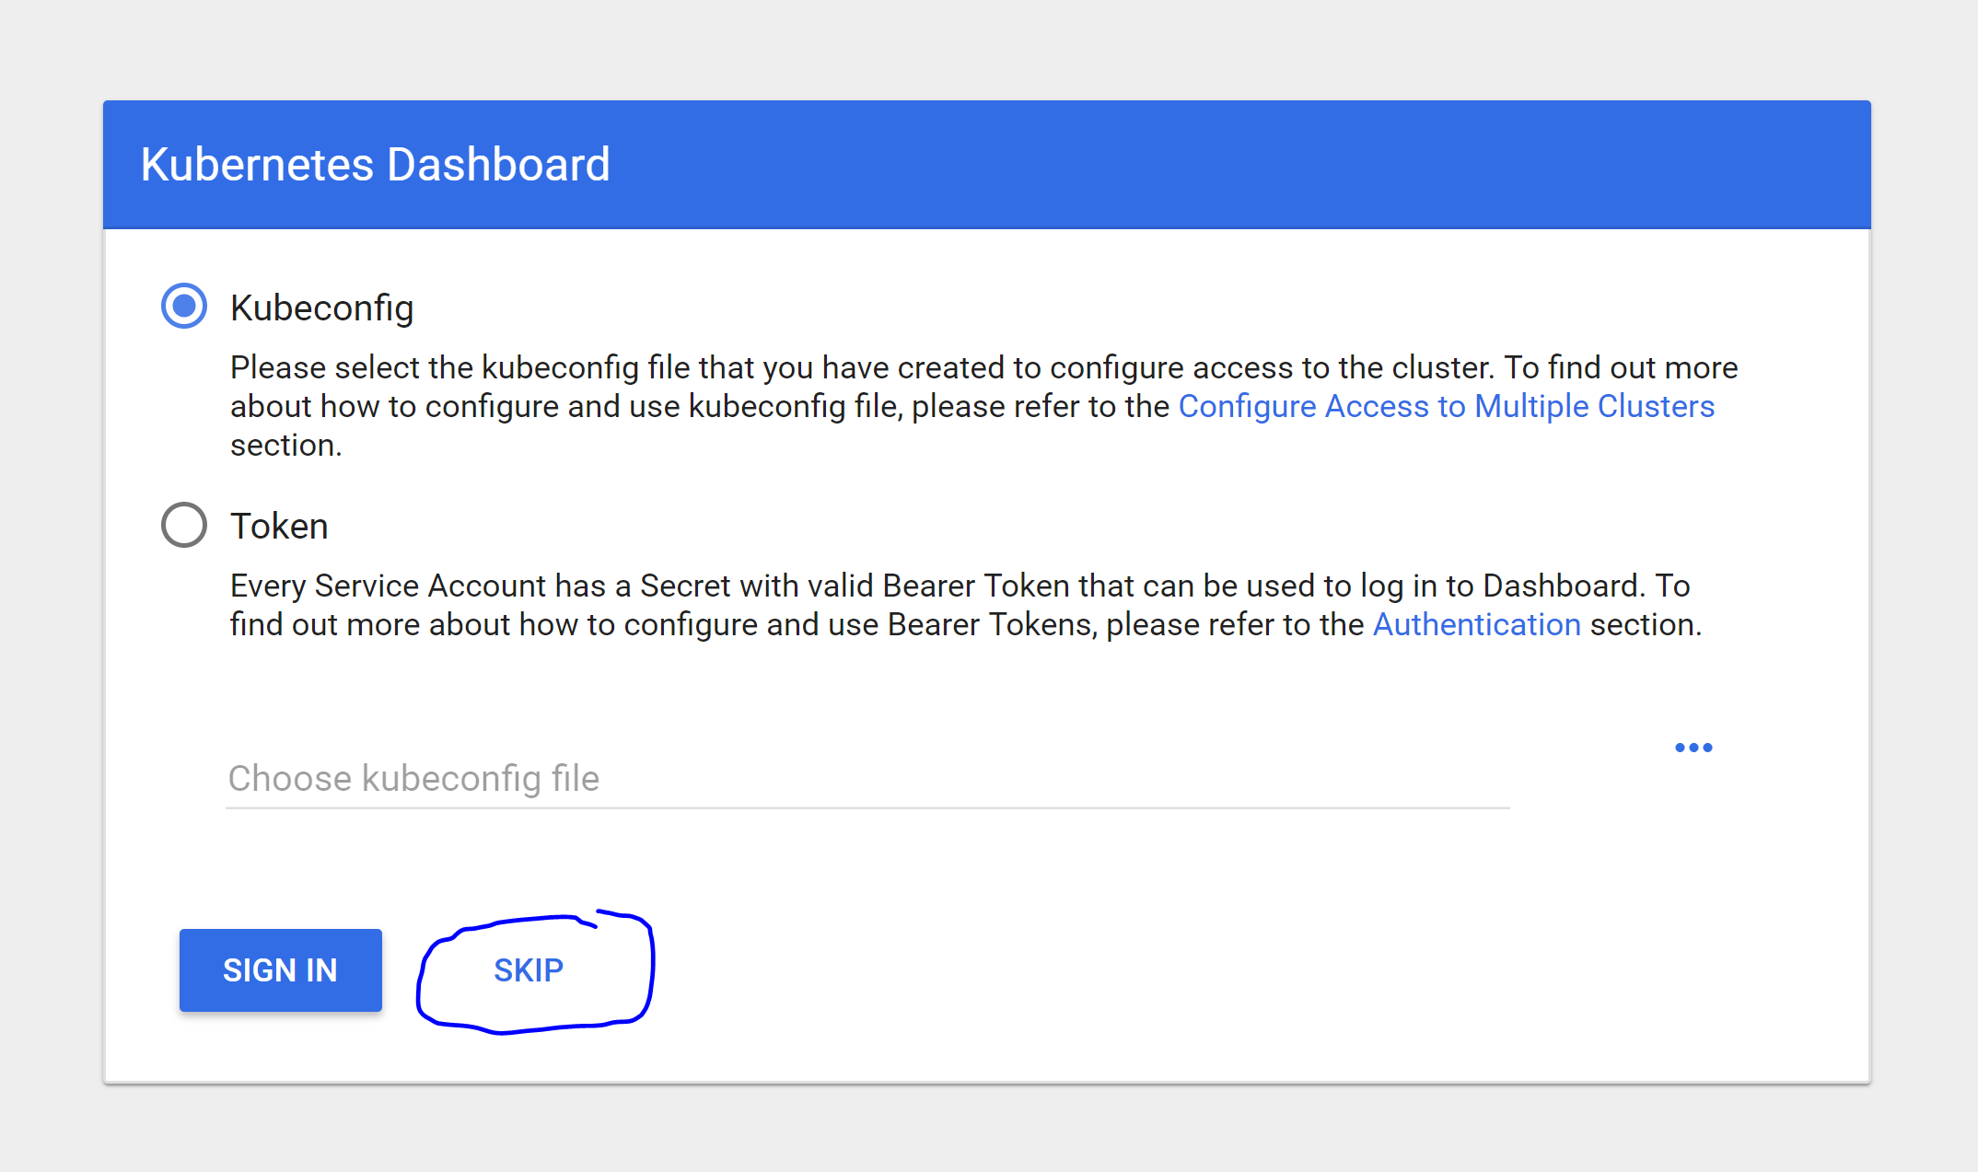

Press skip

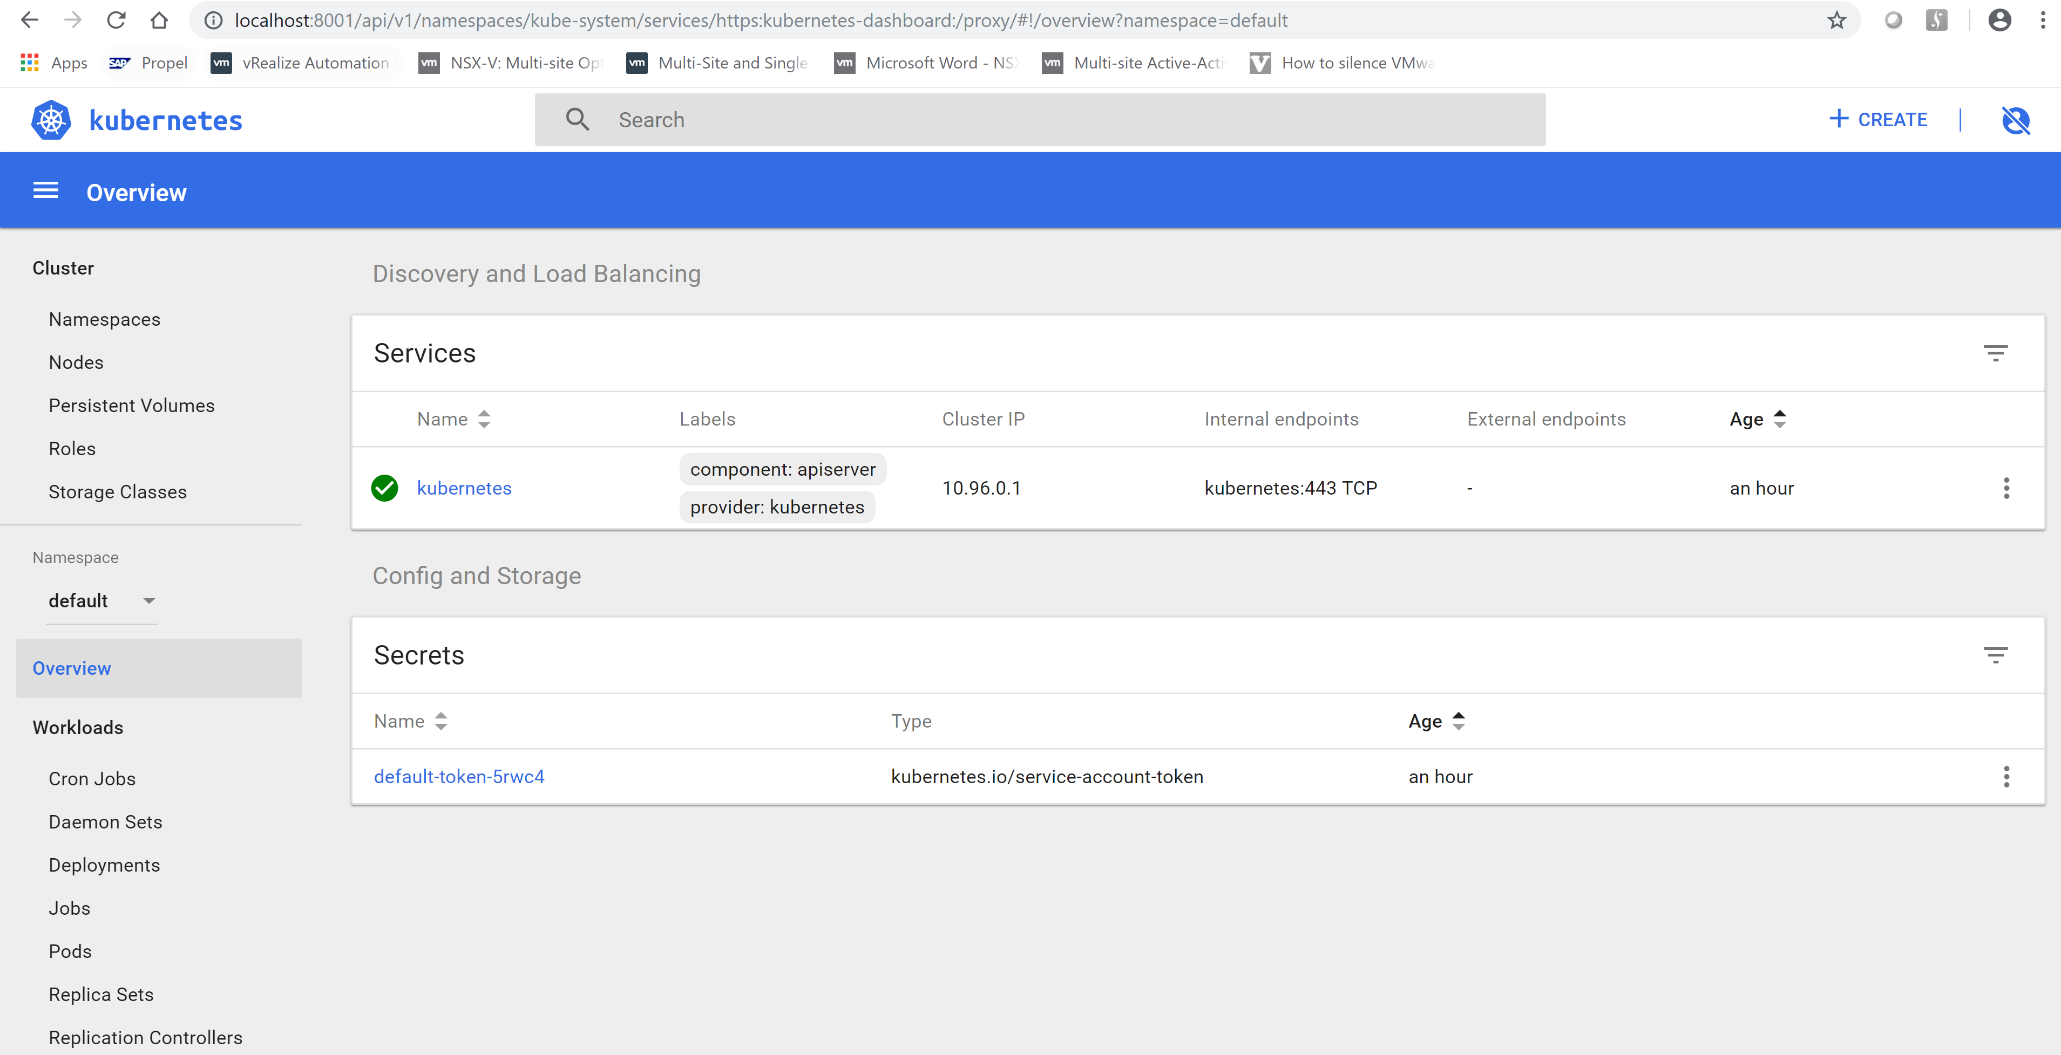

You will see a screen like above

# Installing my first test application

We will use a prebuild container from:

<https://github.com/paulbouwer/hello-kubernetes>

Download the zip, and unzip it

Then use a new cmd prompt to execute the following command

kubectl apply -f yaml/hello-kubernetes.yaml



Let’s check out the application

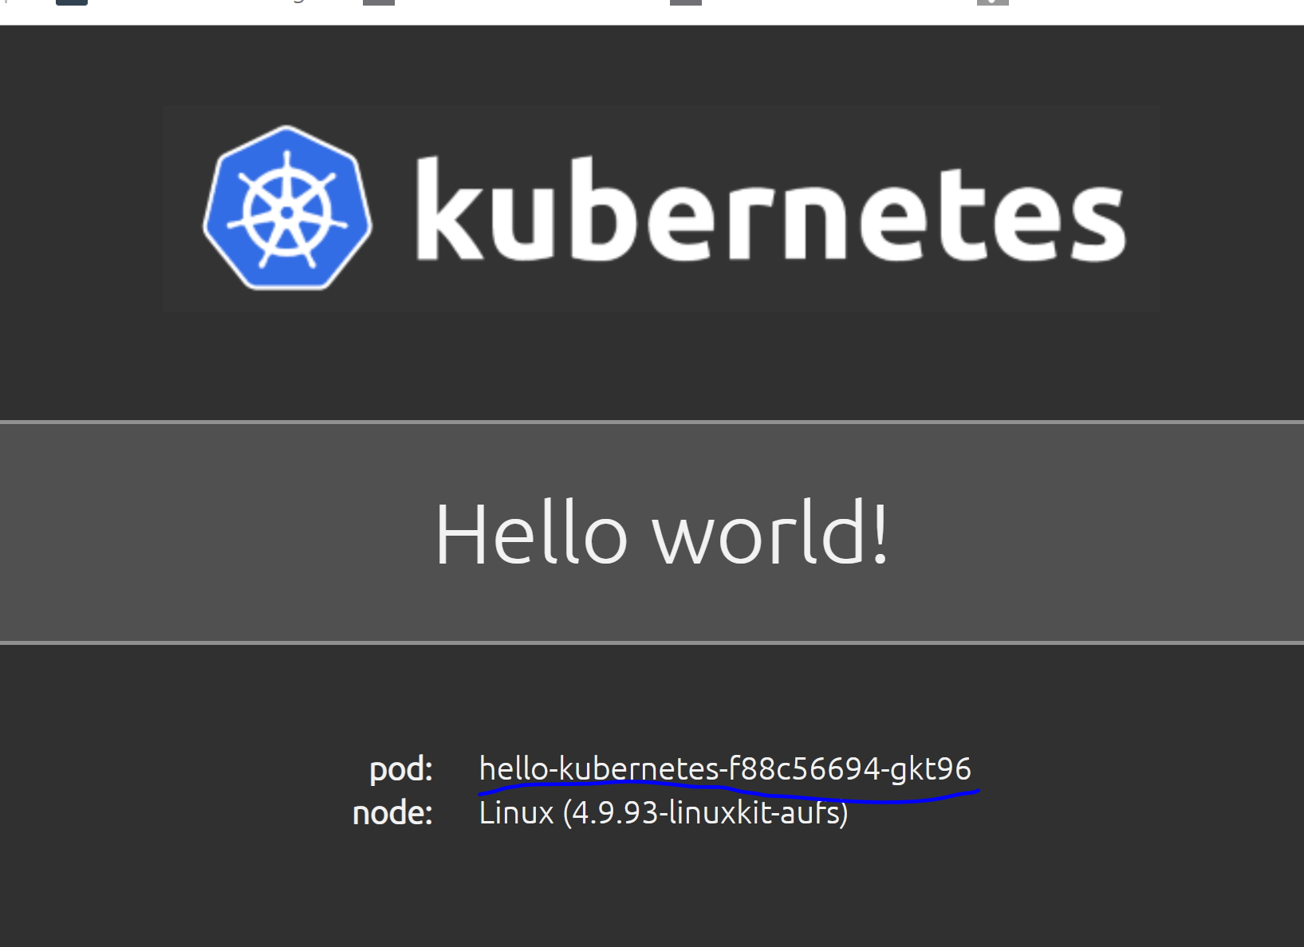

You will see the pod names will change when you refresh your browser and the load balancer balances the load between the different pods.

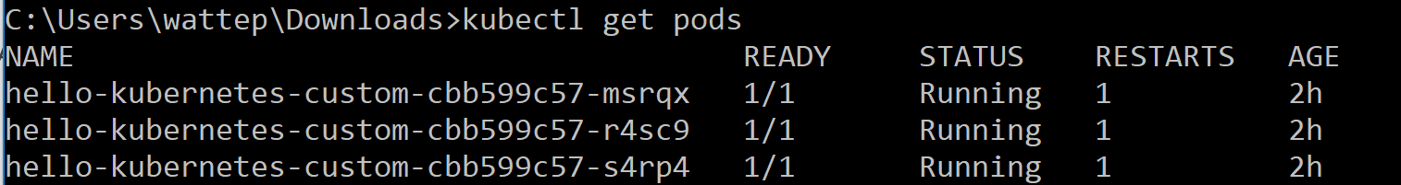

When you do “get pod” you will see the different pod names, and refreshing the browser you will see the web app cycle between them

## Scale

Now let’s scale this app up to 10 instances

Click on deployments and then look for your app, and click the 3 dots and select scale

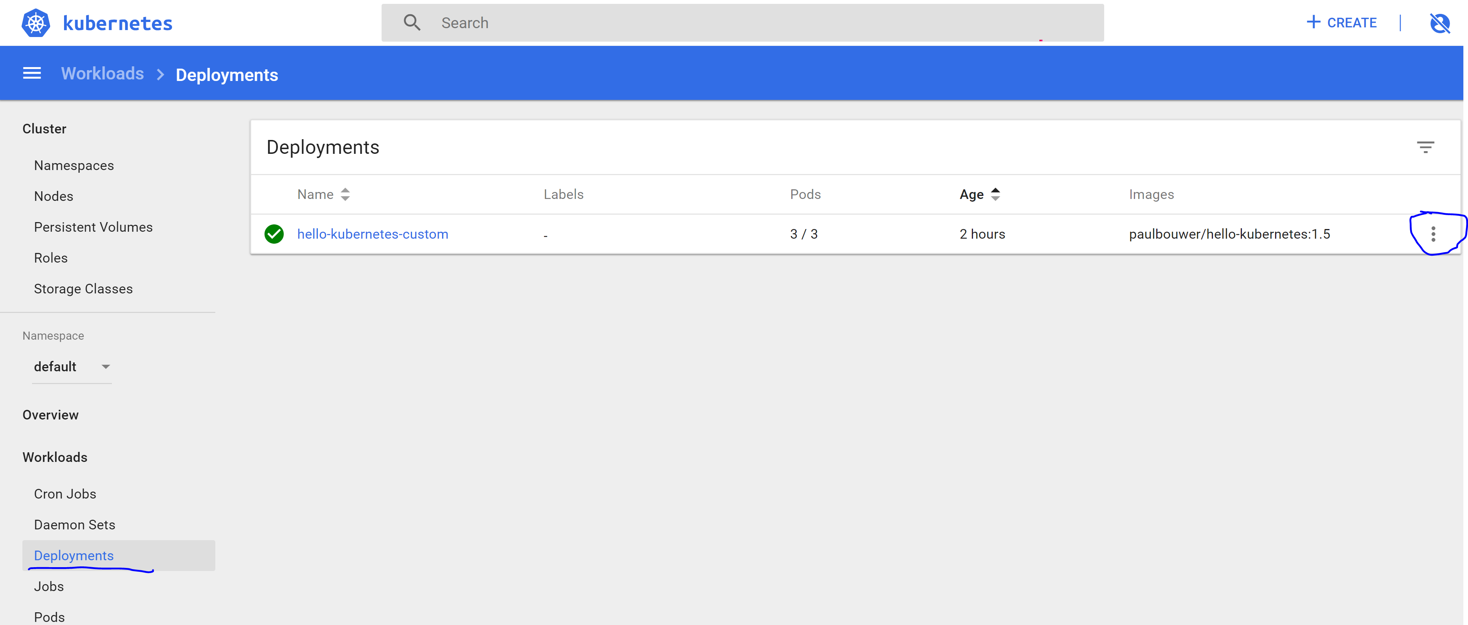

We can scale it to 10 to allow more redundancy and performance.

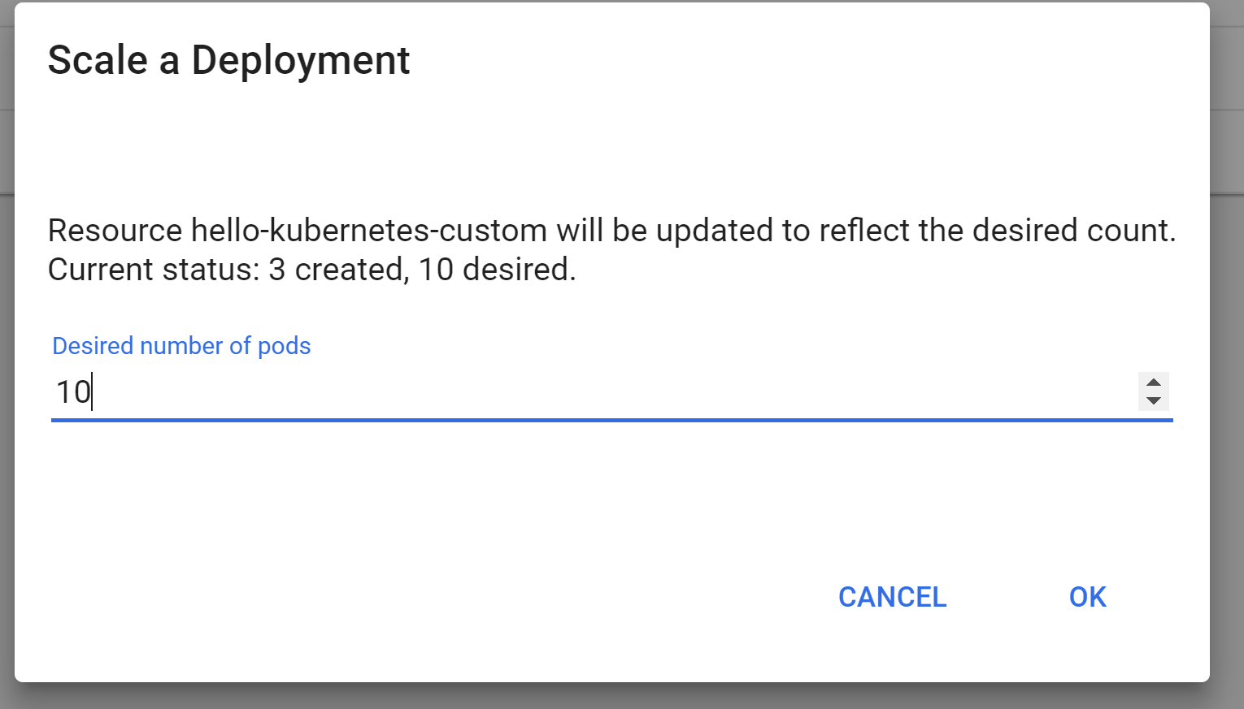

When we click ok, kubernetes will bring up more instances from this app, and when we refresh the browser there will be no down time the scale up or scale down the app.

# Deploying Test nifi on kubernetes

In this chapter we will spin up a test nifi all in one node, with no data persistence.

Meaning when you stop this nifi, all data will be gone!

Create a yaml file on your local machine with the following content:

apiVersion: v1

kind: Service

metadata:

name: nifi

labels:

app: nifi

spec:

type: LoadBalancer

ports:

- port: 8080

targetPort: 8080

selector:

app: nifi

---

apiVersion: apps/v1

kind: StatefulSet

metadata:

name: nifi

spec:

selector:

matchLabels:

app: nifi # has to match .spec.template.metadata.labels

serviceName: "nifi"

replicas: 1 # by default is 1

template:

metadata:

labels:

app: nifi # has to match .spec.selector.matchLabels

spec:

terminationGracePeriodSeconds: 10

containers:

- name: nifi

image: apache/nifi:latest

ports:

- containerPort: 8080

name: nifi

Then execute it as previous:

kubectl apply -f nifi.yaml

Now check how nifi us running:

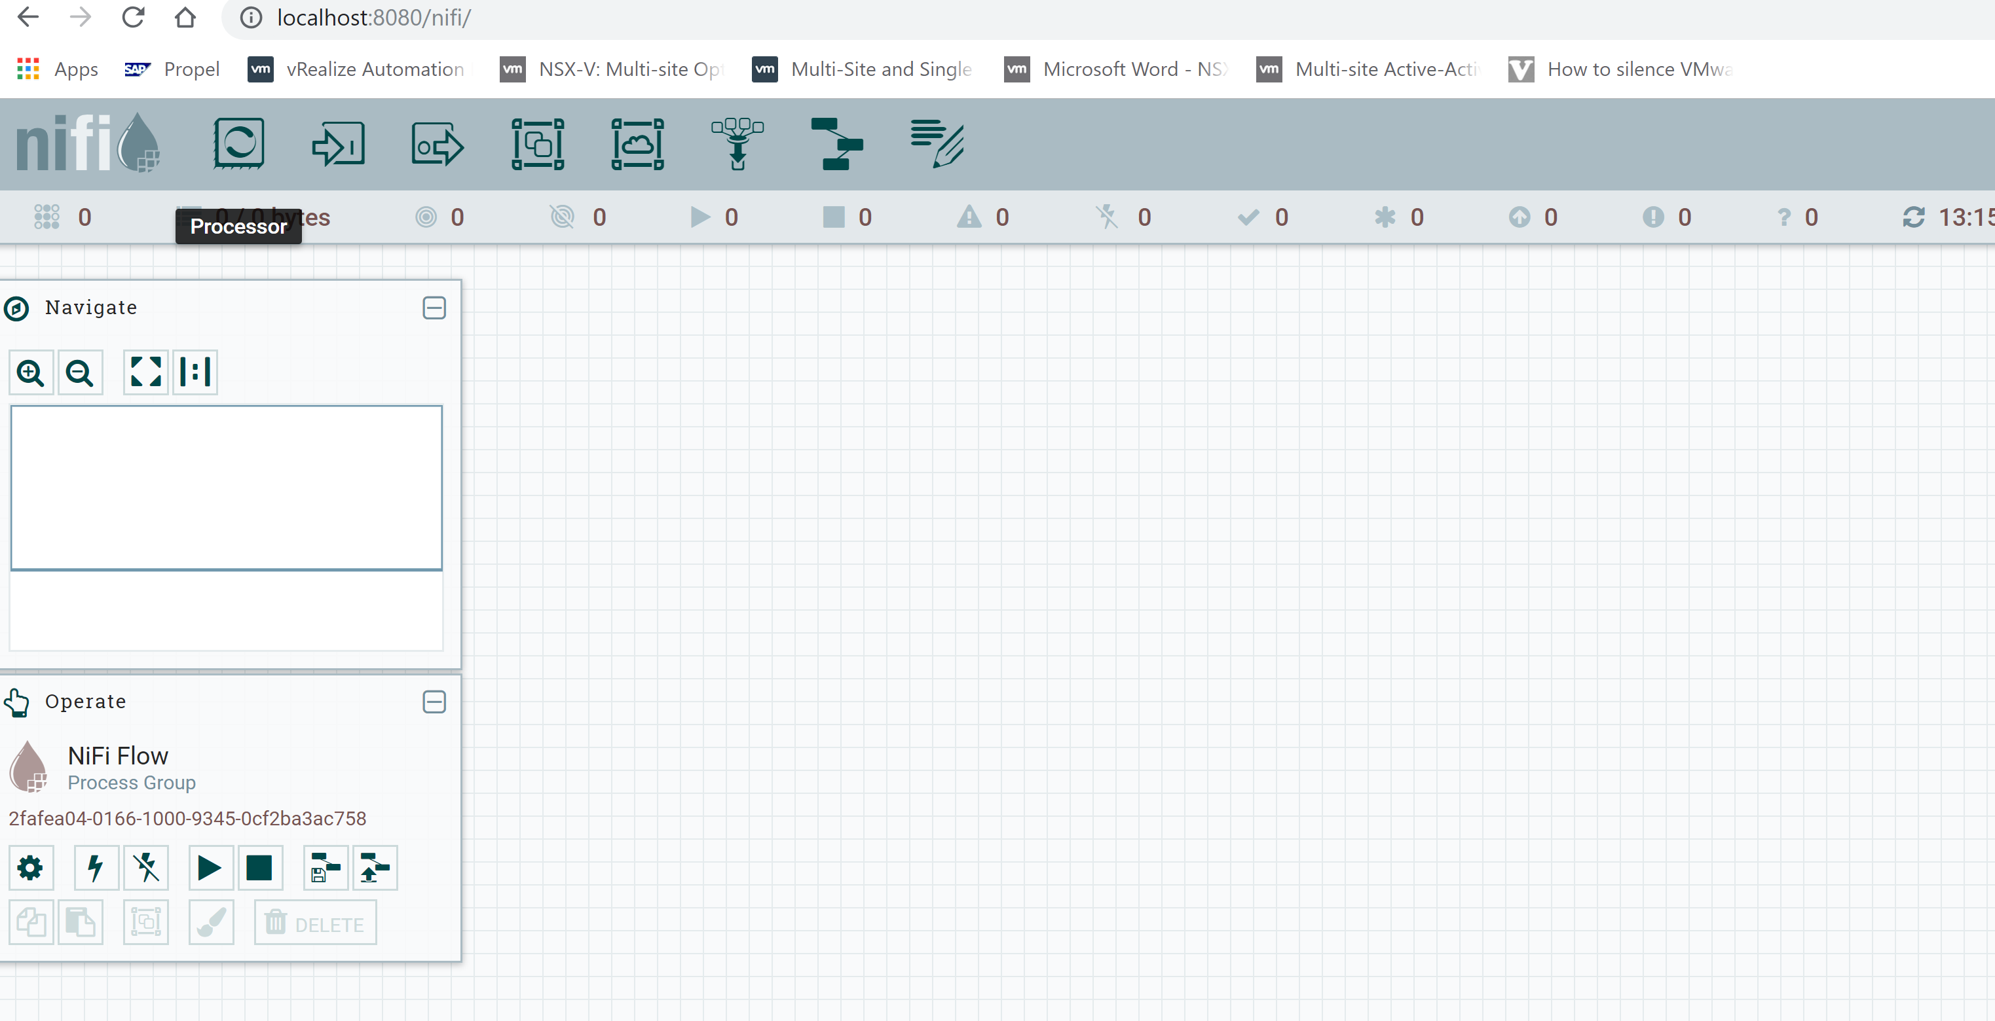

More advanced material will be discussed in the workshops

# Book resources

[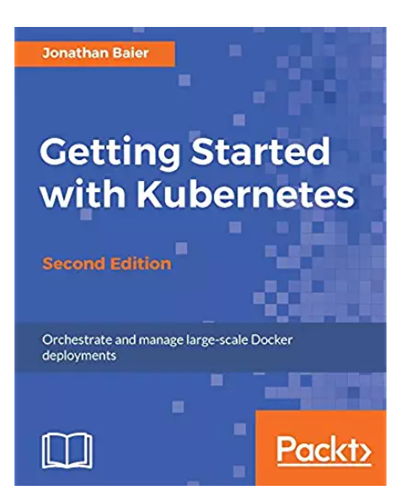](https://www.amazon.com/Getting-Started-Kubernetes-Orchestrate-large-scale-ebook/dp/B01NATUIGO/ref=sr_1_1?s=digital-text&ie=UTF8&qid=1538384084&sr=1-1&keywords=getting+started+with+kubernetes)[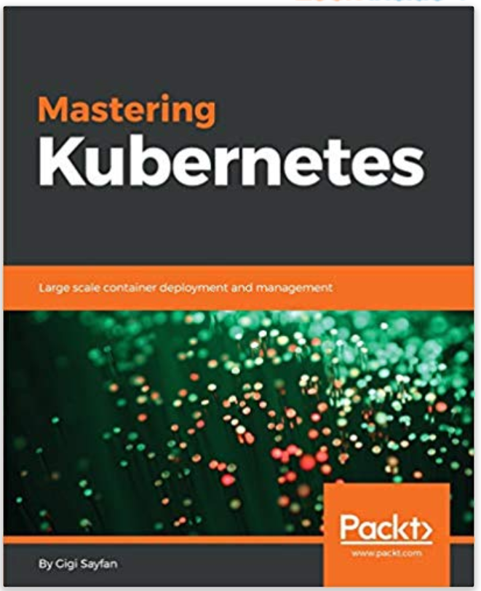](https://www.amazon.com/Mastering-Kubernetes-container-deployment-management/dp/1786461005)

Note: Url Link to Amazon book on the image.

# Appendix

## How do switch hypervisors

bcdedit /set hypervisorlaunchtype off

bcdedit /set hypervisorlaunchtype auto